***Serverless Image processer***

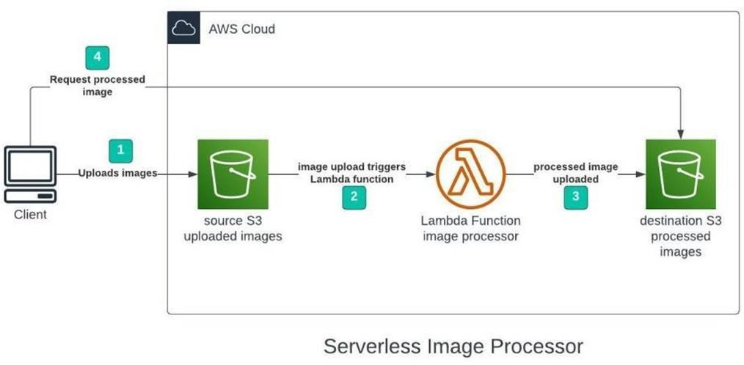

INDEX

1. Sign in to AWS Management Console.
2. Create Two Amazon S3 Buckets (source and target).
3. Create an IAM Policy.
4. Create an IAM Role.
5. Creating Lambda function.
6. Test Lambda Function.
7. Creating S3 Trigger.
8. Upload image in Source Bucket.

# LAB STEPS:-

**Task 1: Sign in to AWS Management Console**

1. Click on the Open Console button, and you will get redirected to AWS Console in a new browser tab.
2. On the AWS sign-in page,
   * Leave the Account ID as default. Never edit/remove the 12 digit Account ID present in the AWS Console. otherwise, you cannot proceed with the lab.
   * Now copy your User Name and Password in the Lab Console to the IAM Username and Password in AWS Console and click on the Sign in button.
3. Once Signed In to the AWS Management Console, Make the default AWS Region as US East (N. Virginia) us-east-1.

* **Create Two Amazon S3 Buckets**

In this task, we will create two AWS S3 buckets i.e the source bucket and the destination bucket by providing the required configurations like name, region etc.

1. Navigate to the **Services** menu in the Top, then click on **S3** in the storage section.

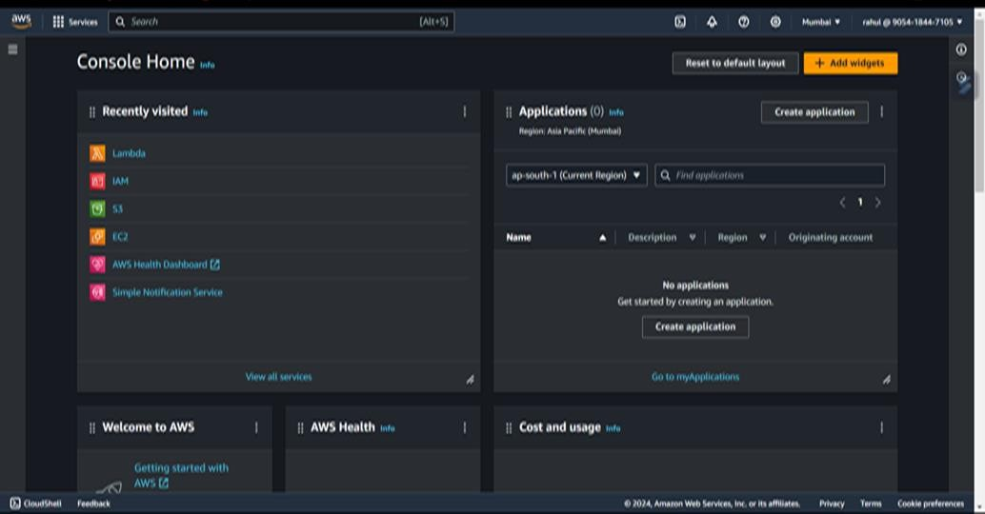

1. Click on Create Bucket button.

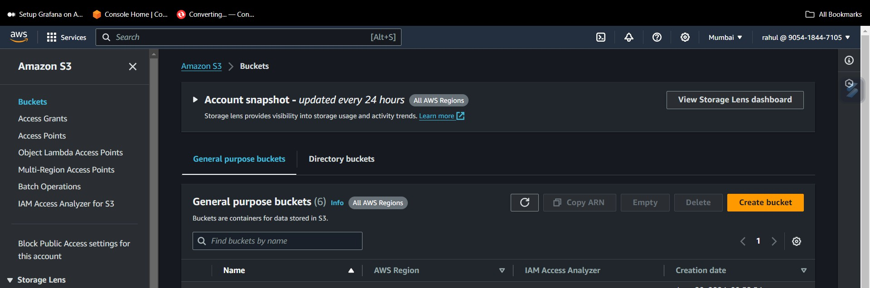

1. Create Source Bucket

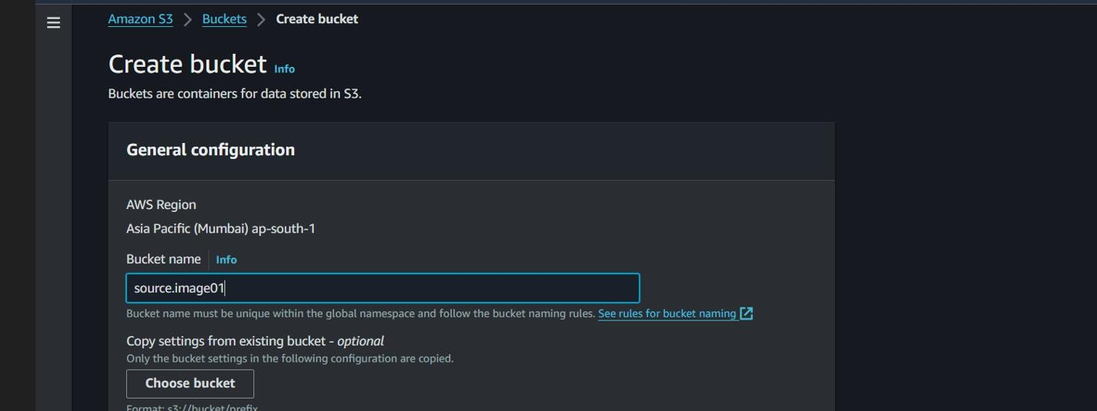

1. Leave Other settings as Default and click on the **Create Bucket** button

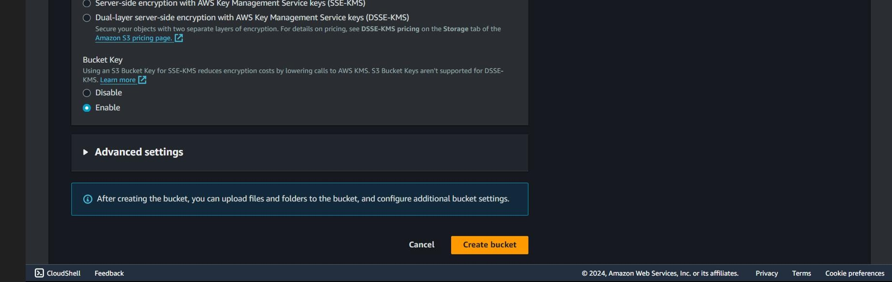

1. Once the Bucket is created successfully, Select your S3 bucket.
   * Click on the Copy ARN button to copy the ARN.
   * Save the source bucket ARN in a text file for later use.
   * arn:aws:s3:::source.bucket01
2. Create Destination Bucket

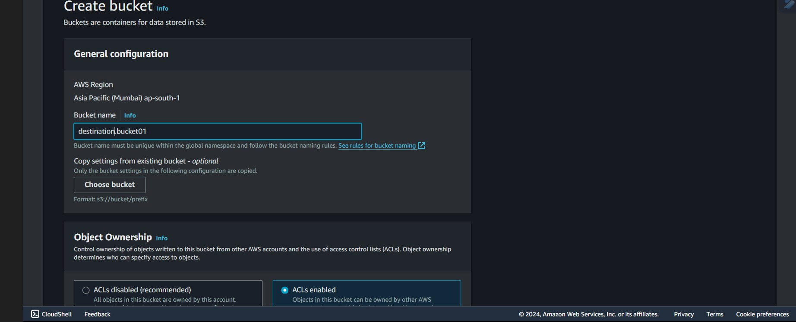

1. Leave Other settings as Default and click on the **Create Bucket** button
2. Once the Bucket is created successfully, Select your S3 bucket.
   * Click on the Copy ARN button to copy the ARN.
   * Save the source bucket ARN in a text file for later use.
   * arn:aws:s3:::destination.bucket01

**Task 3: Create an IAM Policy**

1. Go to **Services** and Select **IAM** under **Security, Identity and Compliance.**
2. Click on **Policies** in the left navigation bar and click on the **Create policy** button.

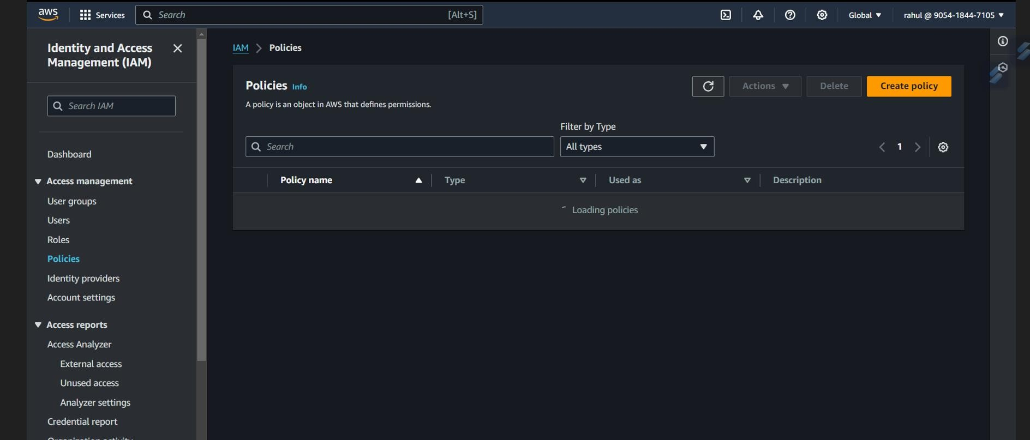

1. Click on the **JSON** tab, Remove the existing code and copy-paste the below policy

statement into the editor:

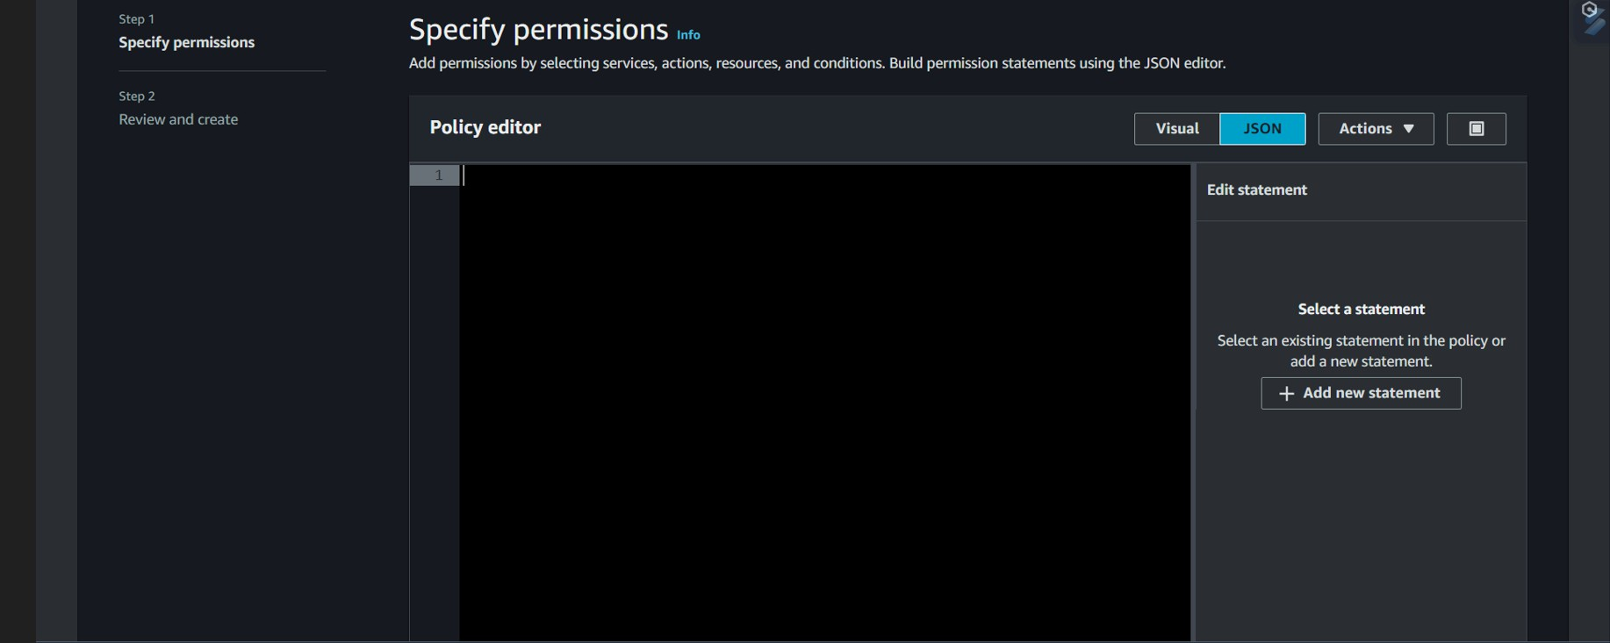

# Policy JSON:

{

"Version": "2012-10-17",

"Statement": [

{

"Effect": "Allow", "Action": [ "logs:PutLogEvents", "logs:CreateLogGroup",

"logs:CreateLogStream"

],

"Resource": "arn:aws:logs:*:*:*"

},

{

"Effect": "Allow",

"Action": ["s3:GetObject"],

"Resource": "arn:aws:s3:::source.bucket01/*"

},

{

"Effect": "Allow", "Action": ["s3:PutObject"], "Resource": "arn:aws:s3:::destination.bucket01/*"

}

]

}

1. Leave Everything as default and click on **Next** button.
2. On the Review Policy page:
3. Enter **Policy Name and** Click on the **Create policy** button

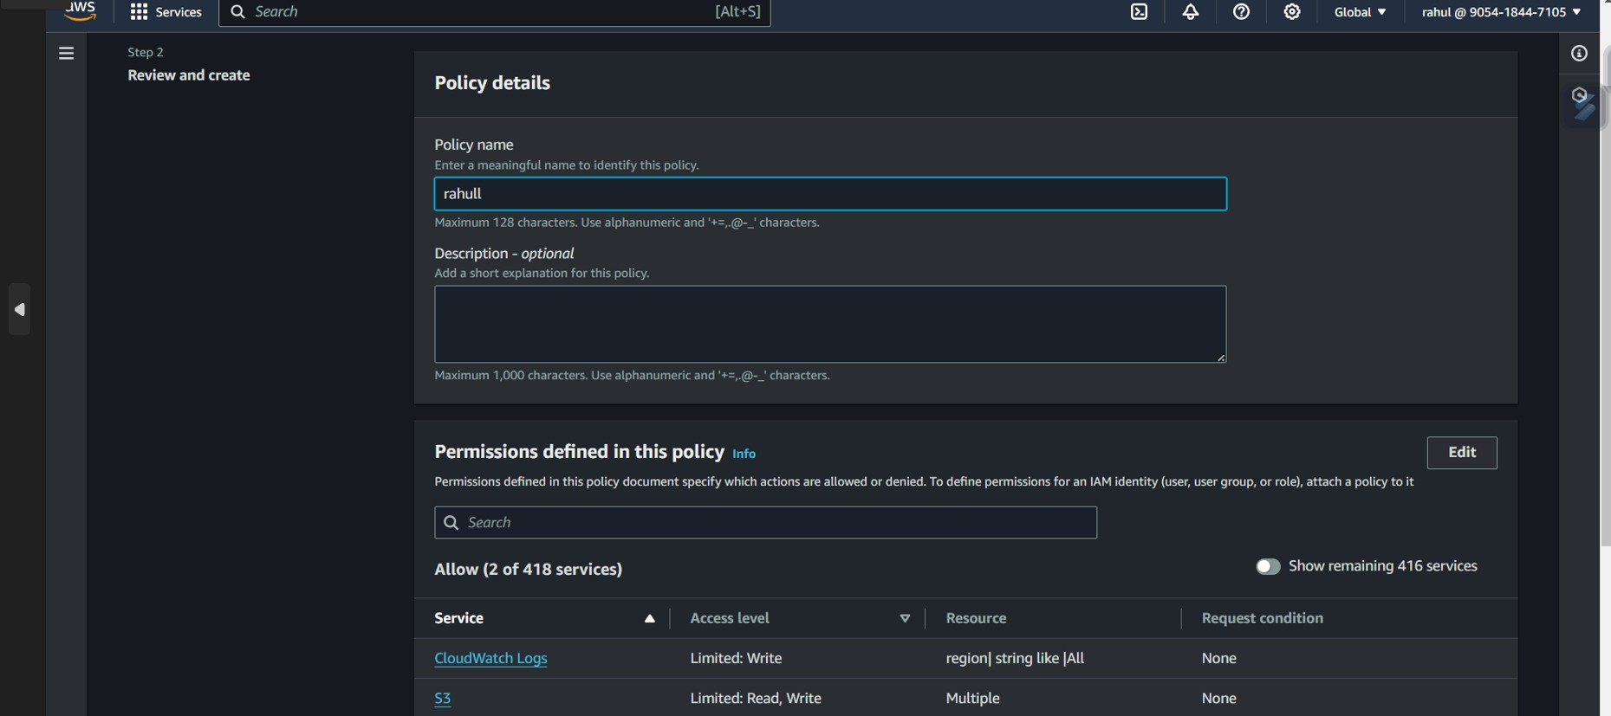

**Task 4: Create an IAM Role**

1. In the left menu, click on **Roles** and click on the **Create Role** button.

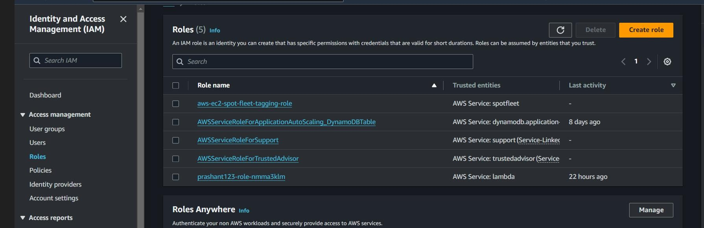

1. Select Lambda from AWS Services list.
   * From Trusted Entity Type: Select AWS Service
   * From Use case: Select Lambda
   * Click on Next button.

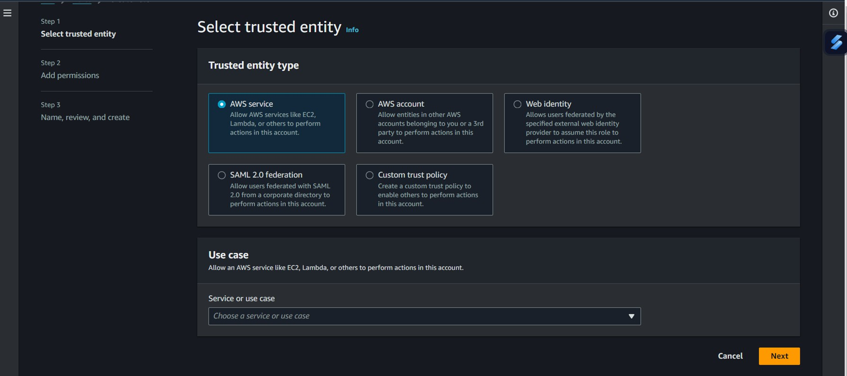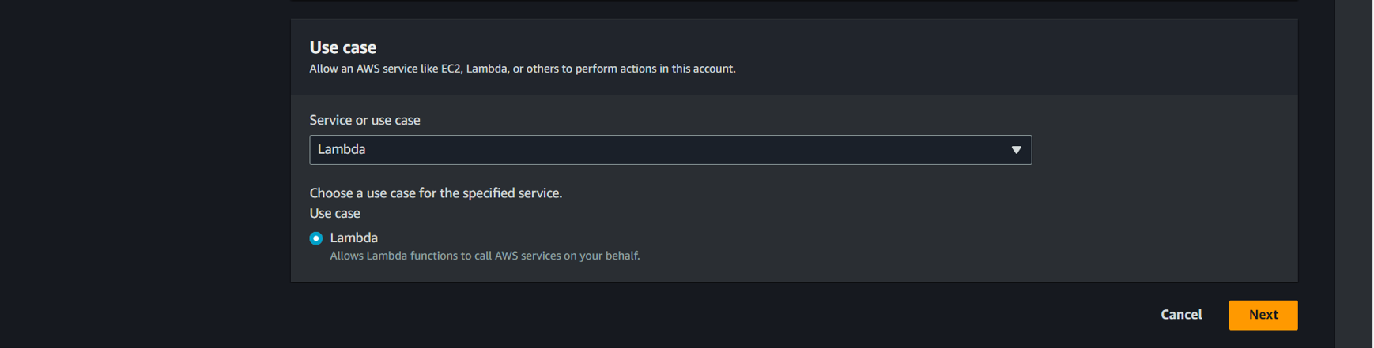

1. Select your **policy** and click on the **Next** button.

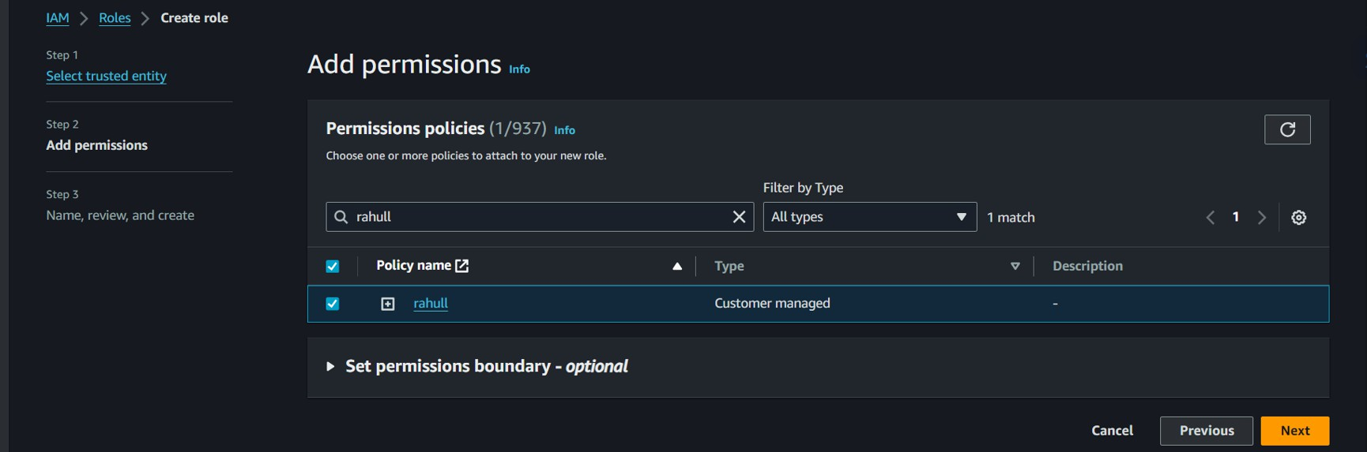

1. **Role Name**: Enter **cloudrole**
2. Click on the **Create Role** button.
   * You have successfully created an IAM role by name cloudrole.

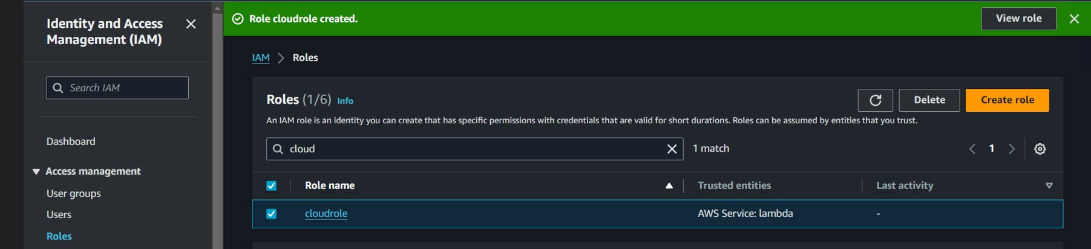

**Task 5: Creating Lambda function**

1. Go to AWS Lambda Console, Navigate to functions section . Click **Create function**

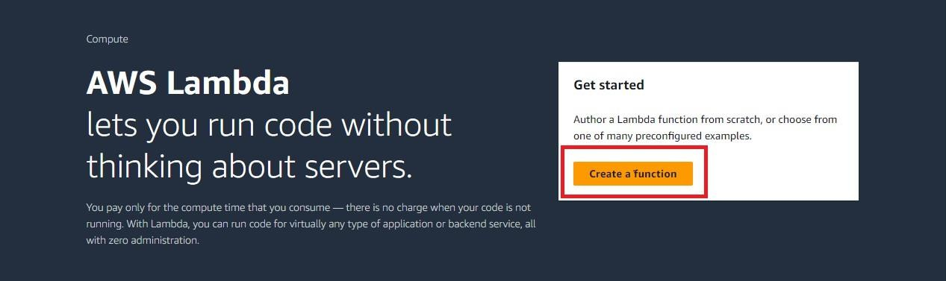

1. Name it and select runtime and Leave all other settings as default.

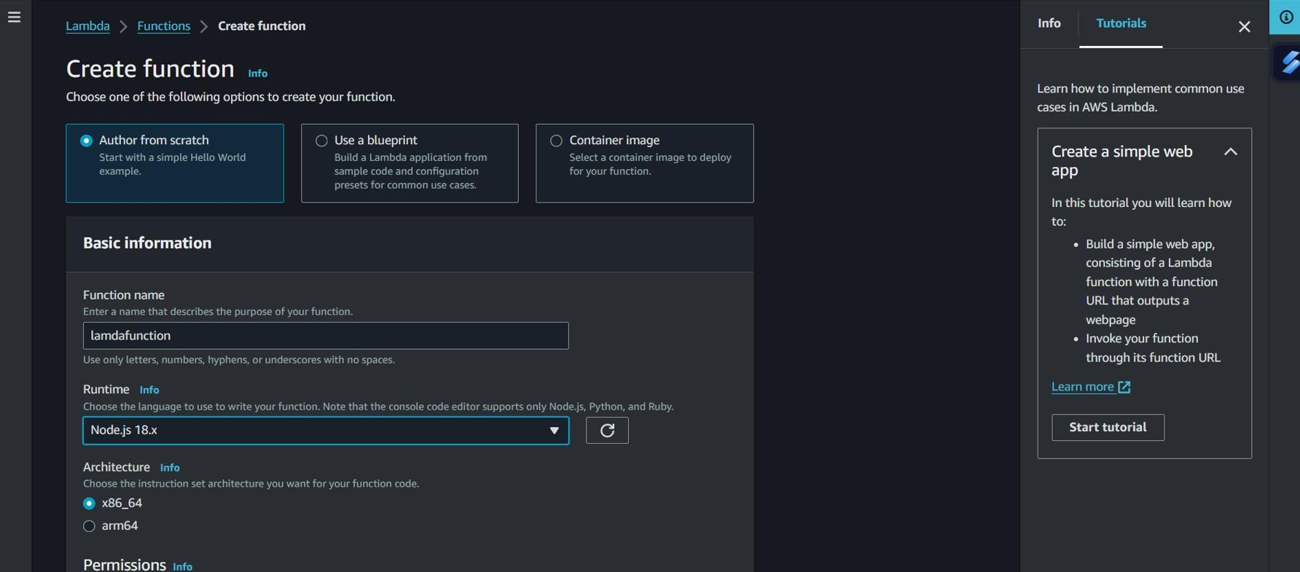

1. Change Default execution role and create function

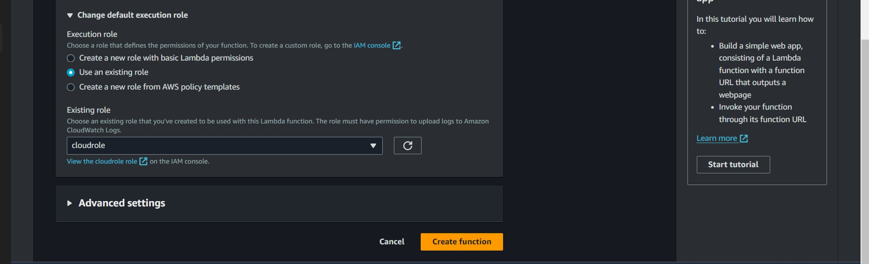

1. Edit Environment Variables

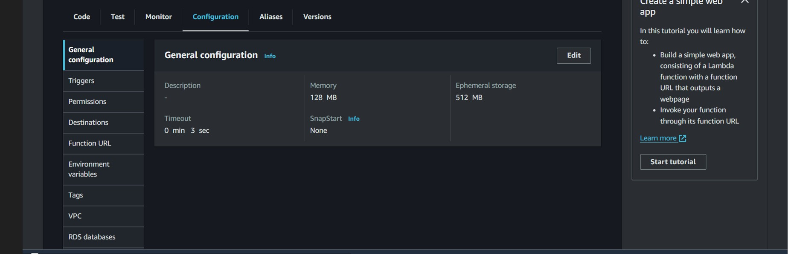

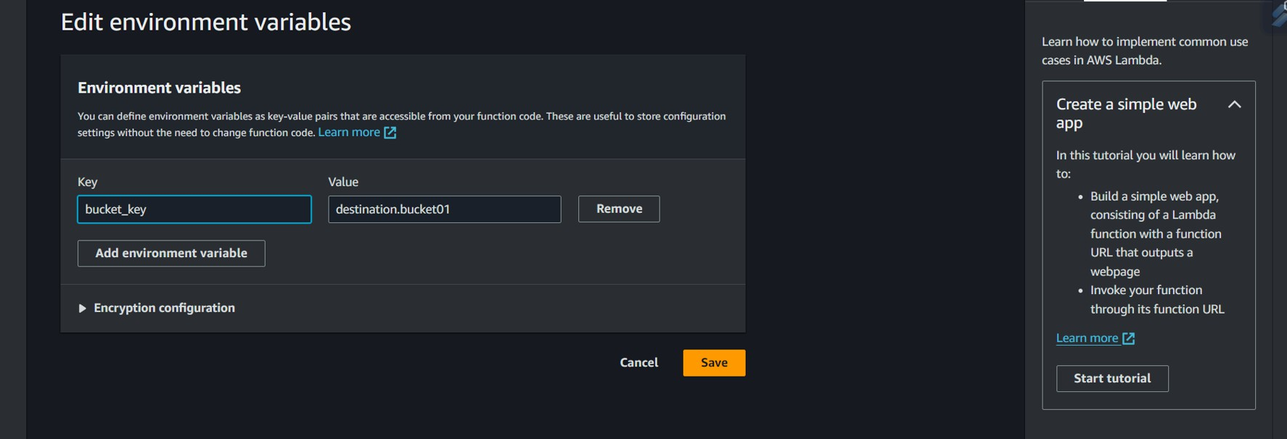

**Task 6: Test Lambda Function**

*Go to AWS Lambda console. Navigate to Functions section.

*open function then will be created

*open test console

*template=s3-put

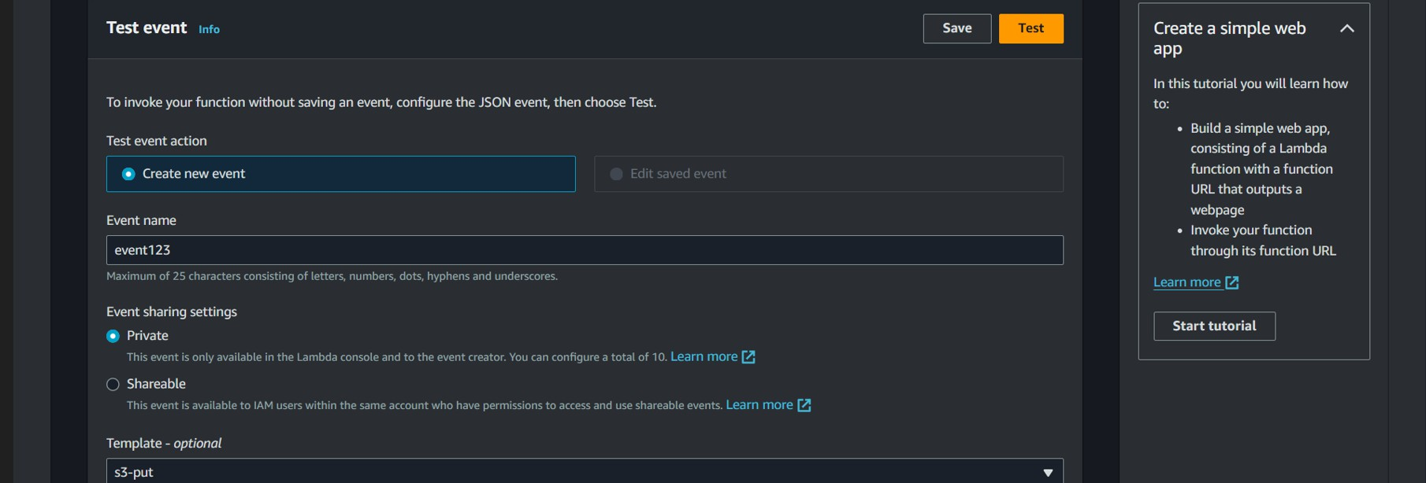

# EVENT JSON:

{

"Records": [

{

"eventVersion": "2.0",

"eventSource": "aws:s3",

"awsRegion": "us-east-1",

"eventTime": "1970-01-01T00:00:00.000Z",

"eventName": "ObjectCreated:Put", "userIdentity": { "principalId": "EXAMPLE"

},

"requestParameters": { "sourceIPAddress": "127.0.0.1"

"sourceIPAddress": "127.0.0.1"

},

"responseElements": {

"x-amz-request-id": "EXAMPLE123456789", "x-amz-id-2": "EXAMPLE123/5678abcdefghijklambdaisawesome/mnopqrstuvwxyzAB CDEFGH"

}, "s3": {"s3SchemaVersion": "1.0", "configurationId": "testConfigRule", "bucket": {

"name": "arn:aws:s3:::source.bucket01", "ownerIdentity": { "principalId": "EXAMPLE"

},

"arn": "arn:aws:s3:::source.bucket01"

},

"object": {

"key": "18981044.jpg",

"size": 1024,

"eTag": "0123456789abcdef0123456789abcdef", "sequencer": "0A1B2C3D4E5F678901" } } } ]

}

**Now We can Test:**

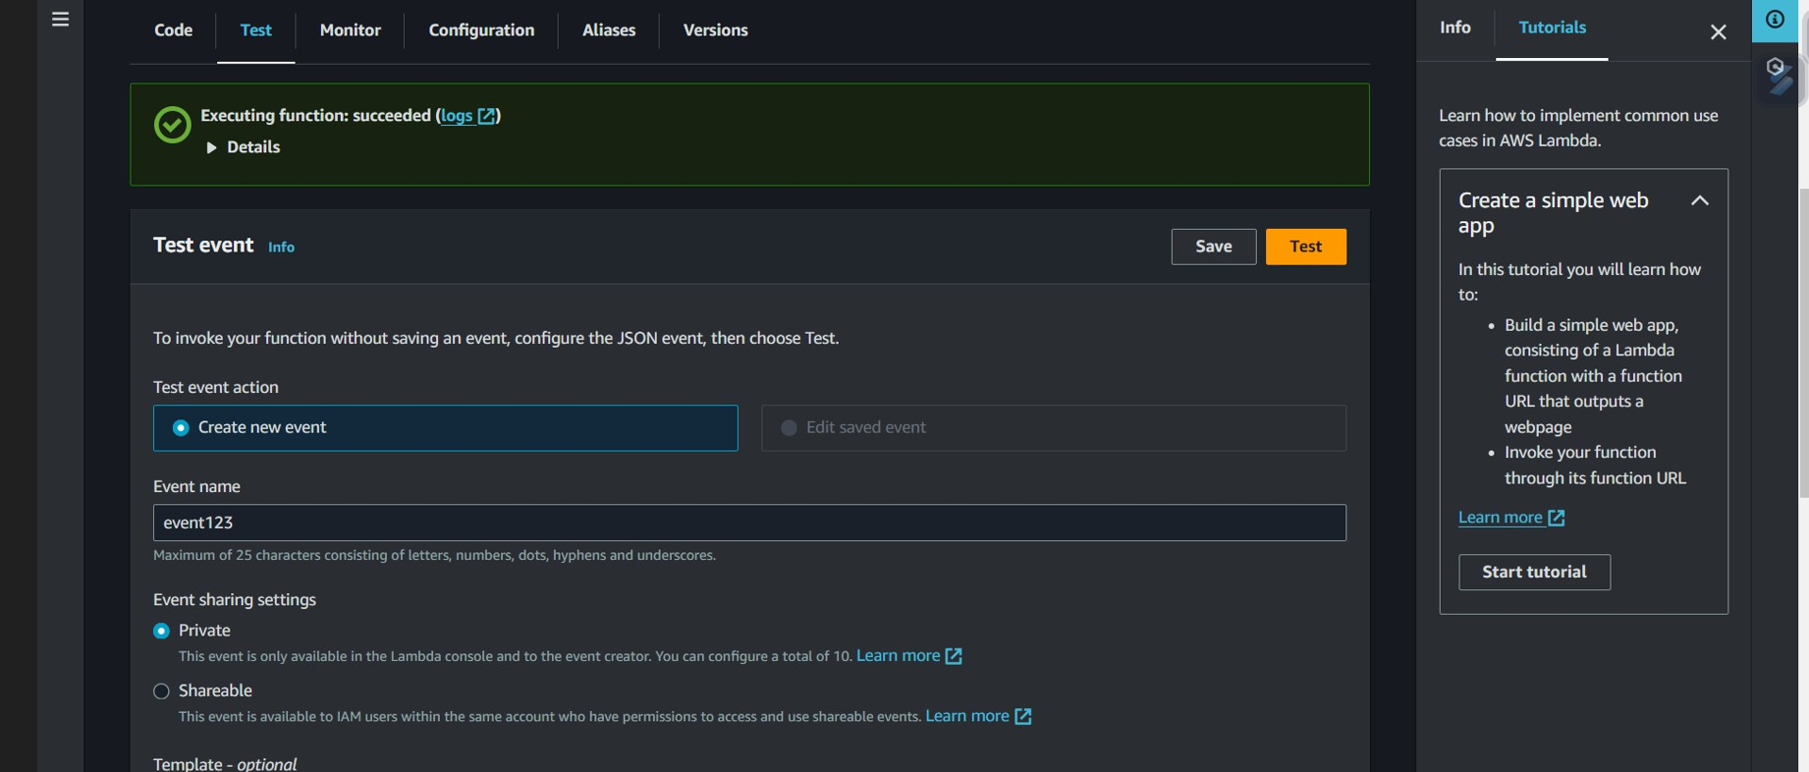

**Task 7: Creating S3 Trigger**

*Add trigger

*Select s3

*choose source Bucket name

*Now Add

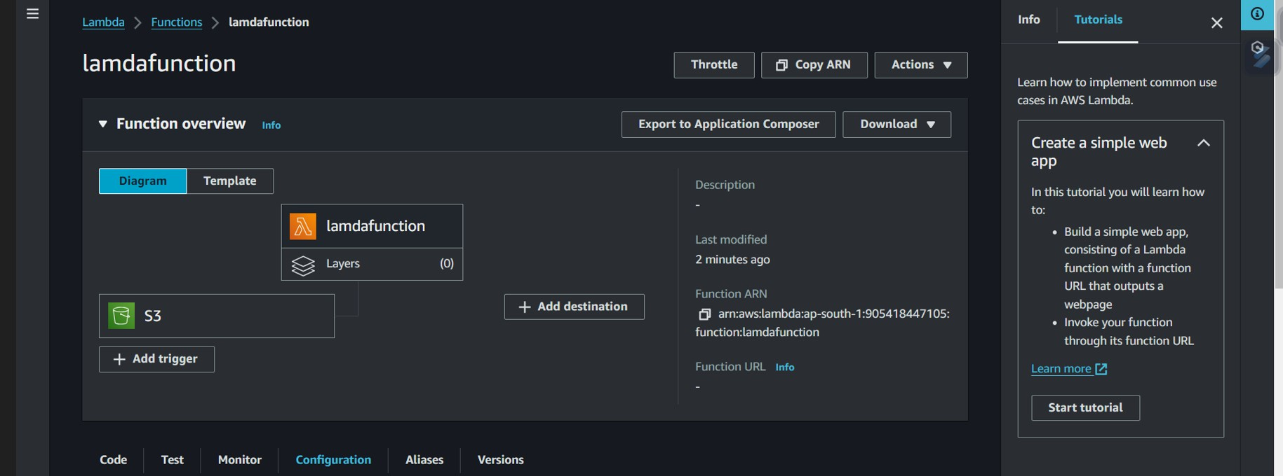

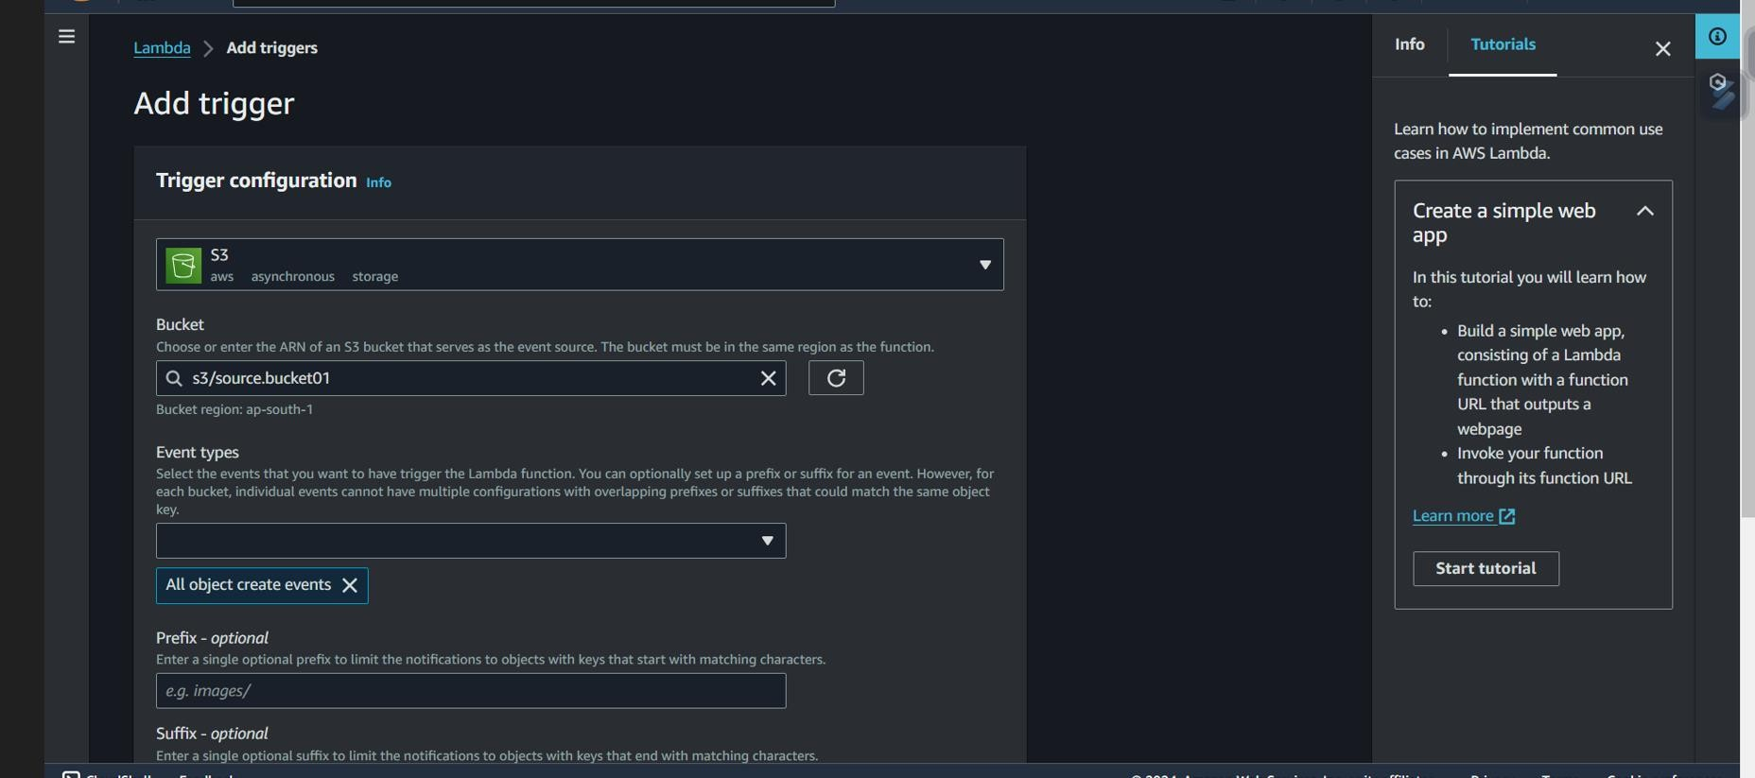

**Task 8: Upload image in Source Bucket**

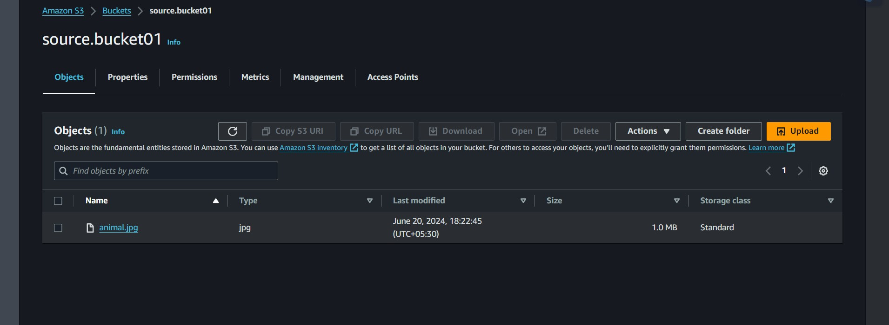

* **Original Image**



* **Destination Bucket**

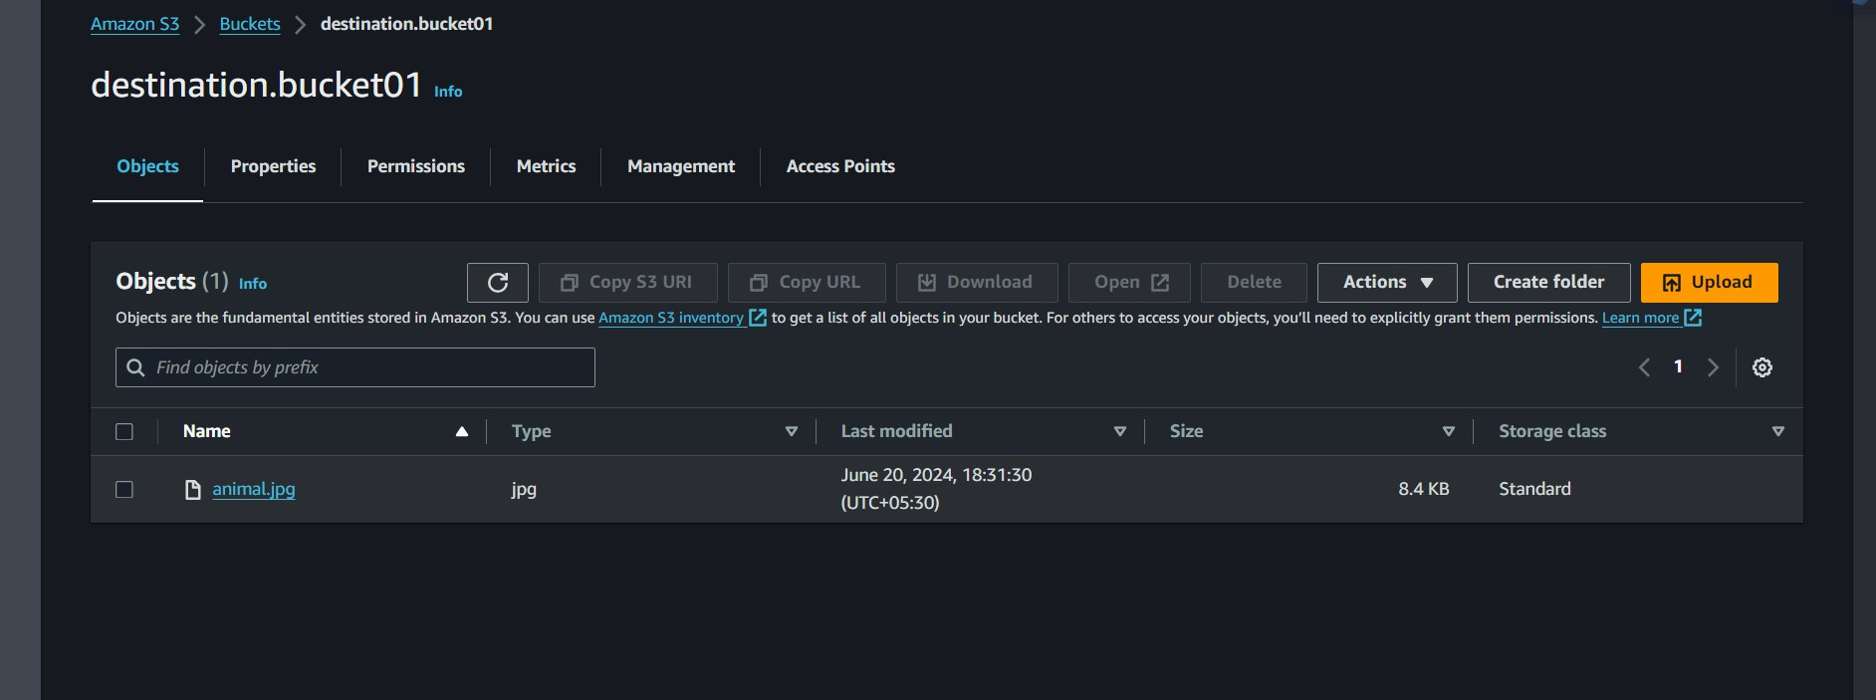

* **Resize Image**

